STM32 Change Report

Version 2

2023.9.4

1. Controller Board Power.schDoc

I have carefully reviewed the Power.schDoc of your Controller Board and noticed that there are a few issues that need to be addressed.

* 12VOUT and PGOOD_12 Net

Specifically, the 12VOUT and PGOOD_12 Nets are not currently defined in the schematic.

After analyzing the board, it seems that these nets may not be necessary for the functioning of the board.

Therefore, I would suggest removing them from the Power.schDoc to streamline the design and avoid any confusion.

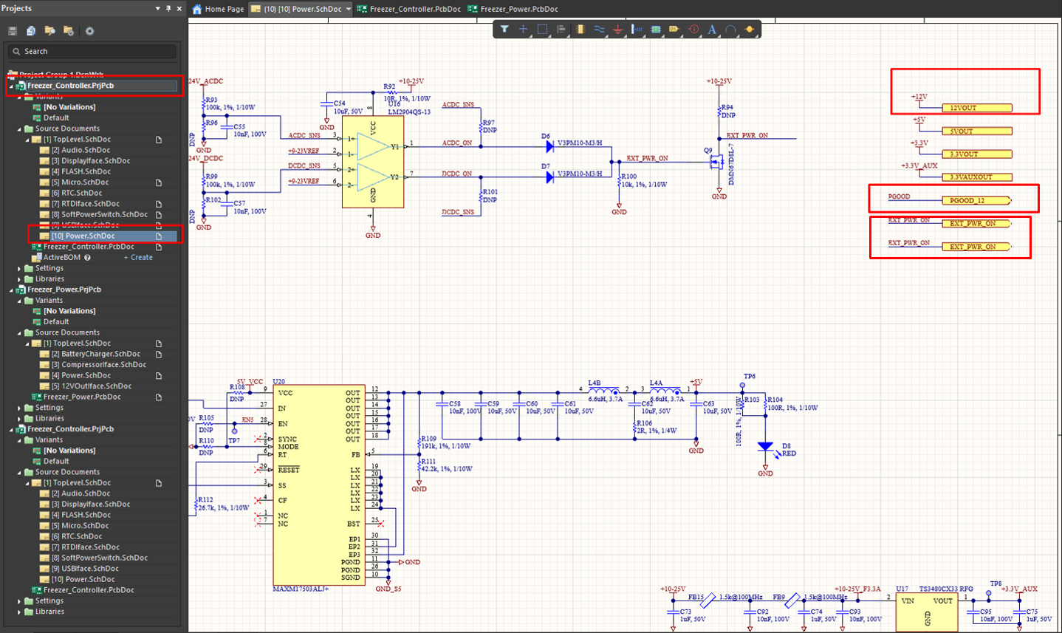

* EXT_PWR_ON Net

On the other hand, the EXT_PWR_ON Net, which is responsible for indicating whether AC or DC power is being supplied, is absolutely necessary for the proper functioning of the board.

However, I have noticed that this net is defined in both the Power and Controller boards, and the MCU uses the EXT_PWR_ON Net defined in the Power board.

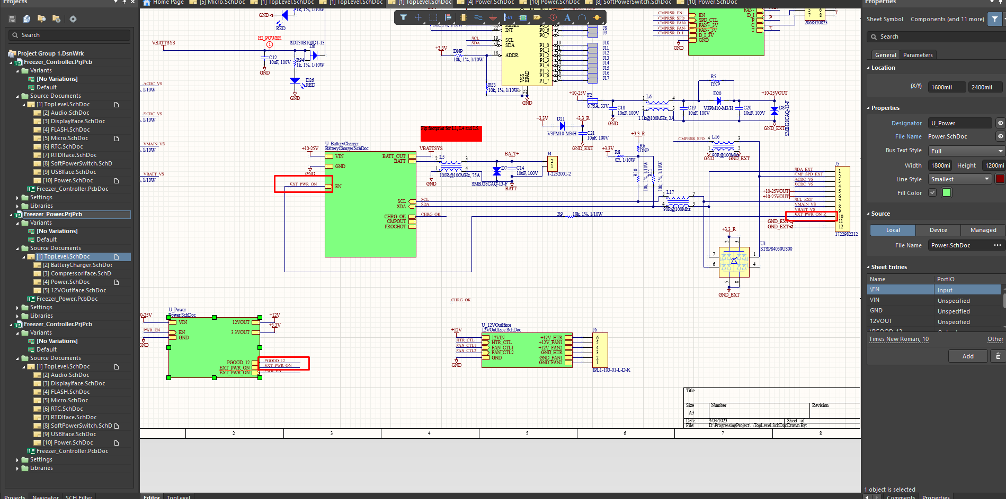

To avoid redundancy and maintain a cohesive design, I propose that we remove the partial schematic defining EXT_PWR_ON in the Power.schDoc of the Controller Board.

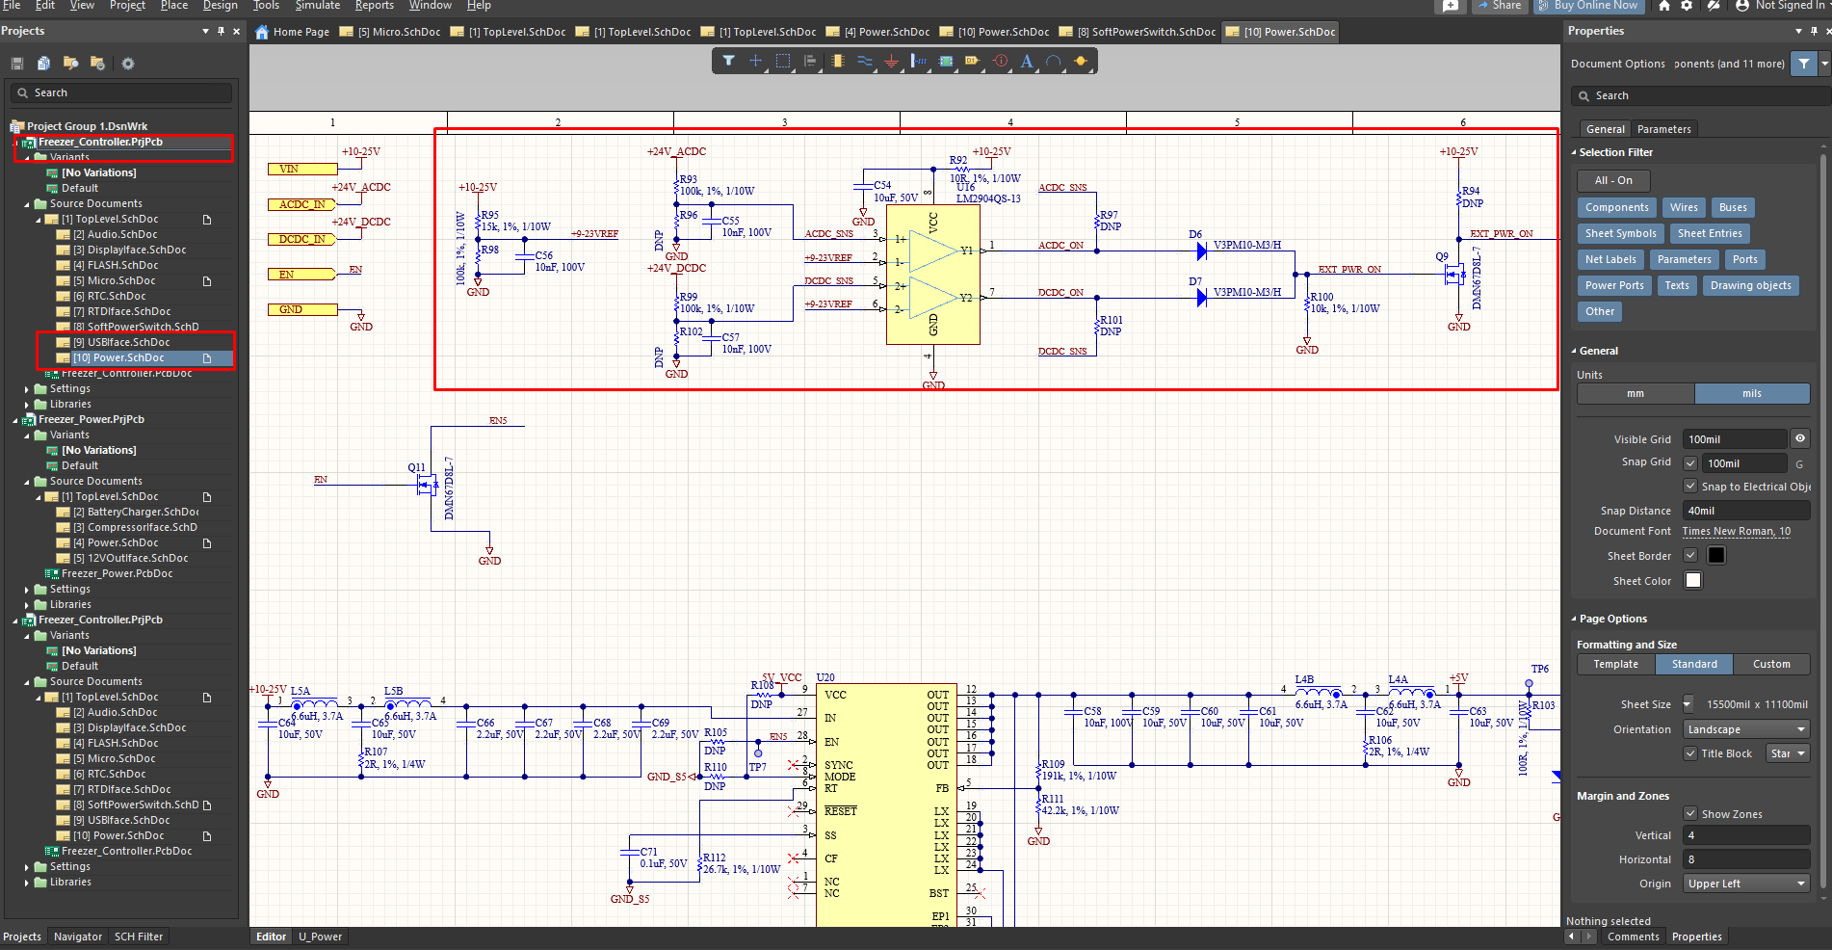

However, if you wish to include this net for the completeness of your design, I would recommend declaring the EXT_PWR_ON Net in the MCU as well.

1. Power Board

PGOOD_12 Net of the power schematic of the power board indicates the output voltage status of 12~25V -> 12V converter.

This Net must be entered into the MCU.

